1st workshop
astrophysical winds and disks
Similar phenomena in stars and quasars
Sponsors
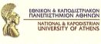 | University of Athens  http://www.uoa.gr
 | Theodore & Erika Spyropoulos
 | Eugenides Foundation  http://www.eugenfound.edu.gr
Alpha Bank
http://www.alpha.gr
 | Culture and Development Network of the Ecological Democracy
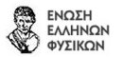 | Hellenic Union of Physicists  http://www.eef.gr
 | “Diavlos” puplications  http://www.diavlosbooks.gr
 | Newspaper “Chronika”  http://xronika05.blogspot.com
 | “Infogenesis”  http://www.infogenesis.gr
 | “Psychogios” Publications  http://www.psichogios.gr
 | http://www.sitemaker.gr/agwn
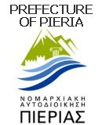 | Prefecture of Pieria  http://www.pieria.gr
 | Municipality of Eastern Olympos
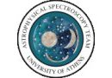 | Astrophysical Spectroscopy Team of University of Athens  http://www.cc.uoa.gr/fasma
Communication Sponsor
 | Newspaper “Eleftherotypia”  http://www.enet.gr

