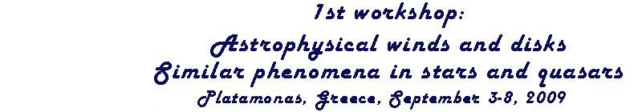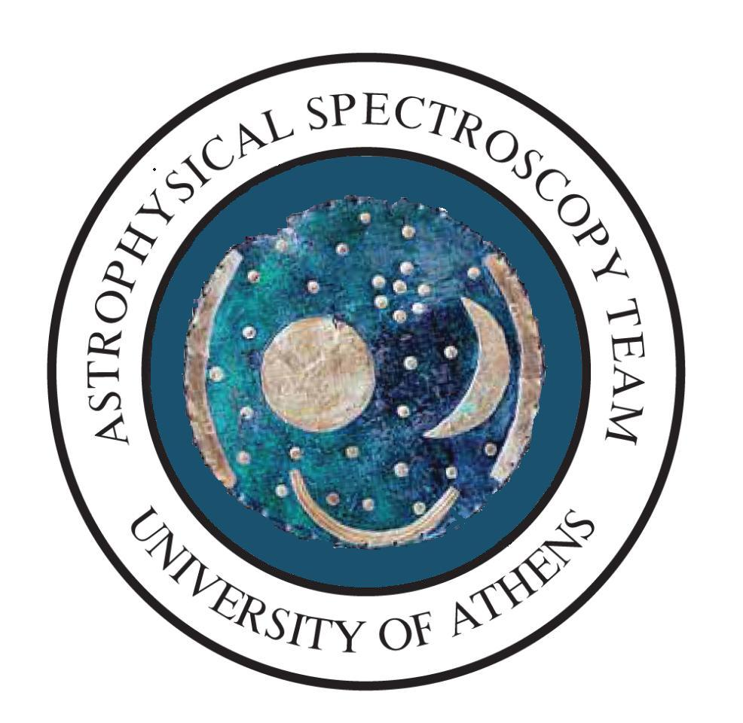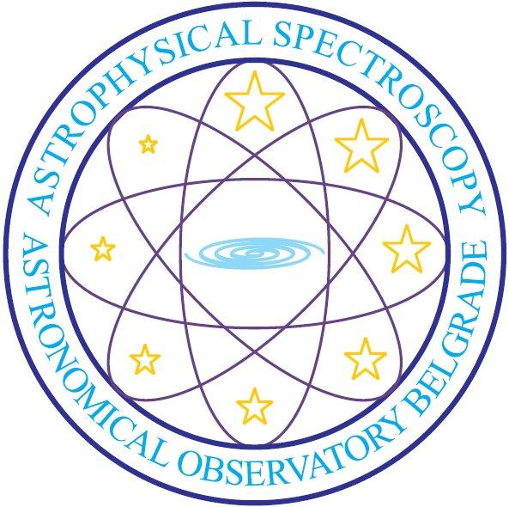
University of Athens
Department of Astrophysics, Astronomy and Mechanics,
Faculty of Physics, University of Athens

Programing
Future Collaborations

Platamonas, Greece, September 3-8, 2009

Propositions

Hot Emission Stars

During this workshop, in the field of hot emission stars, the following propositions have been made:

1. A statistical study of many stars in different ionization potential regions, using the GR model. With the results of this study, we will be able to make a model for all the gaseous areas around hot emission stars.
E. Danezis, A. Antoniou & E. Lyratzi

2. A study of the time scale variation of all the parameters of some characteristic hot emission stars, using the GR model.
E. Danezis, A. Antoniou & E. Lyratzi

The astrophysical spectroscopy teams of the University of Athens and the Observatory of Belgrade are already working on these two propositions, in the frame of the scientific collaboration between Greece and Serbia. Whoever wants to participate in this project is welcome.

3. An experimental study in order to verify the existence of density regions of matter able to construct spectral line (emission or absorption), like the spectral lines that we can detect in the spectra of hot emission stars
J. Purić, N. Cvetanović, B. M. Obradović, I. P. Dojčinović & M. M. Kuraica

This program is the subject of the collaboration between the scientific team of Prof. Puric in University of Belgrade and the Astrophysical Spectroscopy teams of the University of Athens and the Observatory of Belgrade. Whoever wants to participate in this project is welcome.

4. A probabilistic method to extract the exact number of satellite components in which a complex spectral line profile can be decomposed. Through this method, the width and the intensity can also be estimated.
M. Avlonitis & A. Pappa

This program is the subject of the collaboration between the scientific team of Dr. Avlonitis in Ionian University and the Astrophysical Spectroscopy team of the University of Athens. Whoever wants to participate in this project is welcome.

If there is another proposition, we expect an abstract, in order to include it in the final proposition.
5. Proposition of Magdalena Christova (no abstract)
6. Proposition of Zoran Simic (no abstract)

Quasars

During this workshop, in the field of quasars, the following propositions have been made:

1. A study of the physical parameters of many spectral lines of a group of quasars using a combination of GR model and disk model.
E. Danezis, E. Lyratzi & A. Antoniou

The astrophysical spectroscopy teams of the University of Athens and the Observatory of Belgrade are already working on these two propositions, in the frame of the scientific collaboration between Greece and Serbia. Whoever wants to participate in this project is welcome.

2. There are many observed spectra collected by the group of Prof. Piero Rafanelli, who proposed to use these spectra for all kind of investigation of quasars.
P. Rafanelli
Interested in this proposition:
1. Astrophysical spectroscopy team of University of Athens.
2. Astrophysical spectroscopy team of Astronomical Observatory of Belgrade
3. Dr. Magdalena Christova, Department of Applied Physics, Technical University of Sofia, Bulgaria

3. Edi Bon proposed to collaborate in developing a two-component model especially, to apply this model on different spectra of quasars.

4. Proposals of Predrag Jovanovic are to investigate the emission of the accretion disk around super-massive black holes, supposed to be in quasar center. Also, some micro-gravitational influence on line profiles emitted from the disk.

5. Finally, we have a proposition from Markos Avlonitis from the Ionian University, which combines most of the previous propositions in one, aiming to a European financing.

General Conclusions
1. There are four groups which will collaborate in the subject of “Investigation on the nature and structure of Active Galactic Nuclei, using emission/absorption lines” (Belgrade, Athens, Ionian University, Goettingen and Padova group). It would be incorporate in planed PF7 proposal.

2. All the participants are invited to agree in a common collaboration for a PF7 proposal. This collaboration has been proposed by Markos Avlonitis (Ionian University), Manos Danezis, Valia Lyratzi, Anastasia Pappa and Antonis Antoniou (University of Athens). It has been agreed that the proposal will be sent electronically to all the participants, in order to make comments and suggestions. Whoever is interested in this collaboration is invited to participate in. A next step is to decide on the supervisor of the PF7 proposal. The proposal has been written by Anastasia Pappa and is the following:

Proposal for a possible FP7 collaboration

Understanding the physical mechanism in hot emission stars, AGNs and quasars

Following the round table discussions during this workshop, it has emerged a common theme of interest - the understanding of the physical mechanism that produces the spectra in hot emission stars, AGNs and quasars using a variety of complementary methods and techniques.

Here we propose that we unite our efforts under an FP7 proposal. A successful submission of an fp7 proposal will allow us to coordinate our efforts better, provide funding for travelling, organising similar workshops and meetings and provide financial support to hire researchers.

Below there is a short description of the scientific case for building this collaboration towards an fp7 proposal. This section could provide the framework in which the complete scientific case can be finalised.

Hot emission stars, AGNs and quasars show complex spectra. The detailed study of their spectra can unlock the physical mechanism that powers them and unveil a range of interesting and exotic phenomena.

To achieve this, we study observational data and use mathematical modelling techniques to derive kinematical parameters of the lines. This, in turn allows us to test theoretical models. To that end the astrophysical spectroscopy team of the University of Athens has already developed a model which gives the properties of the lines in hot emission stars (apparent rotational and radial velocities, the random velocities of the ions, the Full Width at Half Maximum, the optical depth, the column density and the absorbed or emitted energy). Using those parameters they can describe the structure of the regions that produce the observed lines in hot emission stars. However, in order to study and to model the whole area around hot emission stars (Be and Oe stars), in UV, we have to calculate the parameters of many regions with different ionization potential (e.g. N V, C IV, N IV, Si IV, Al III, Fe II, Mg II, Lyα, Hα. Using their GR model, we can calculate many parameters of the density regions where the studied spectral lines are created. They have concluded that the lines are produced in independent density regions around the star. Further work includes a statistical study of many ions in different ionization potential regions of many stars. With the results of this study, they will be able to make a model for all the gaseous areas around hot emission stars. Time scale variation of all the parameters of some characteristic hot emission stars is also required. Finally the model could be extended to allow for the modeling of the region around AGNs and quasars.

On the other hand, Avlonitis M. and Pappa A. proposed a stochastic method for deriving some of the line parameters in complex line profiles, which allow the exact reconstruction of the lines. According to this method the lines may be treated as random signals which can be considered as superposition of independent signals. The number of independent signals can then be considered equal with the number of the interfered lines that make up the complex line profile. The results of that method can then be fed into the mathematical modelling applications such the one used by the Athens group and return results with the highest possible confidence level.

Towards the understanding of the mechanism that produces the line profiles in stars, AGNs and quasars Purić J. et al. propose to apply some methods from laboratory plasma which could enable us to shed light into the physical conditions in this region. By simulating in laboratory the physical conditions of the gaseous envelope or disk around hot emission stars and quasars they expect to find out if density regions similar with the ones that create the DACs and SACs lines in hot emission stars and quasars can be created in the laboratory as well as resultant light absorption.

Using those techniques we could for the first time tackle the issue of astrophysical winds and disks in stars, AGNs and quasars in a complete manner.

Please note that many other round table participants contributed their ideas, which could now be discussed in more detail and be included in a possible fp7 proposal.

