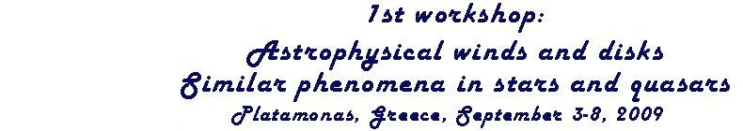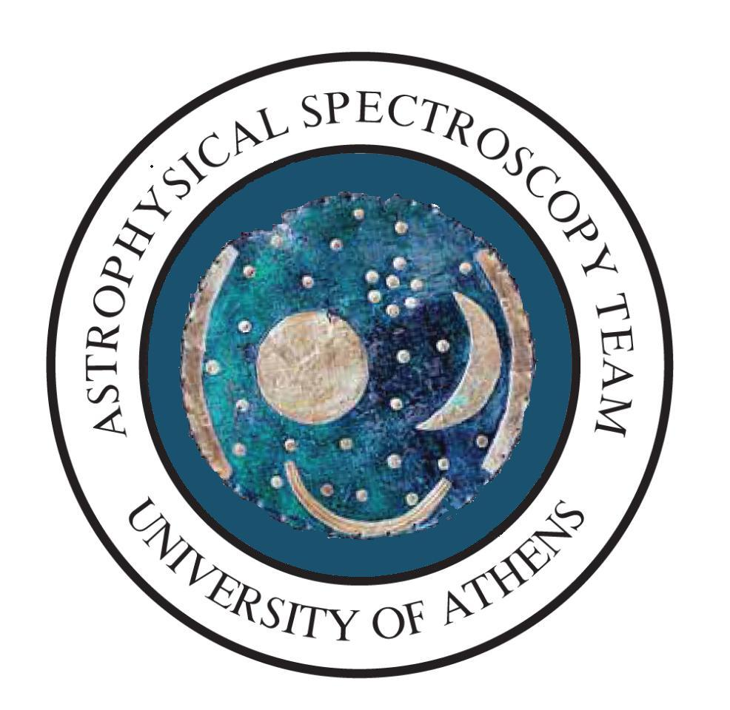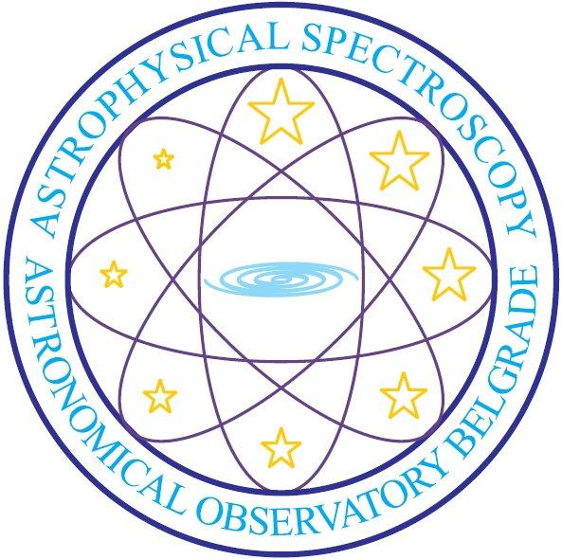
University of Athens
Department of Astrophysics, Astronomy and Mechanics,
Faculty of Physics, University of Athens

Abstracts
Invited Lectures
Poster Papers

Platamonas, Greece, September 3-8, 2009

A.
Joint Session on
Hot Emission Stars and Quasars
Introduction
Studying the Complex Spectral Line Profiles in the Spectra of Hot Emission Stars and Quasars
E. Danezis¹, E. Lyratzi^{1,2}, A. Antoniou¹, L. Č. Popović³, M. S. Dimitrijević^{3,4}, E. Theodossiou¹
1. Department of Astrophysics, Astronomy and Mechanics, Faculty of Physics, University of Athens, Panepistimioupoli, Zographou 157 84, Athens, Greece
2. Eugenides Foundation, 387 Sygrou Av., 17564, Athens, Greece
3. Astronomical Observatory of Belgrade, Volgina 7, 11060 Belgrade, Serbia
4. Observatoire de Paris, 92195 Meudon Cedex, France
e-mail: edanezis@phys.uoa.gr, elyratzi@phys.uoa.gr, ananton@phys.uoa.gr, lpopovic@aob.bg.ac.yu, mdimitrijevic@aob.bg.ac.yu, etheodos@phys.uoa.gr

Abstract
In this review we present quickly the scientific fruits of collaboration between the spectroscopy teams of the University of Athens and the Observatory of Belgrade. We discuss how the complex absorption lines in spectra of hot emission stars and quasars, created in the material around stars/quasars (here density regions of matter around the objects). Particularly we present a model (GR model) which is developed to study Satellite or Discrete Absorption Components (DACs or SACs). Using the model we are able to extract kinematical parameters (rotational, radial and random velocity) and some physical parameters (Full Width at Half Maximum, optical depth in the center of the line, column density and absorbed or emitted energy) of the density regions. Additionally, we discuss very large widths observed in some absorption lines. Finally we present the open scientific questions of this field and the future scientific program of our team.
Invited Lectures
Towards a Probabilistic Approach for DAC Exact Reconstruction
M. Avlonitis¹ & A. Pappa²
1. Ionian University, Department of Informatics, 7 Tsirigoti Square, 49100 Corfu, Greece
2 Department of Astrophysics, Astronomy and Mechanics, Faculty of Physics University of Athens, Panepistimioupoli, Zographou 157 84, Athens, Greece
e-mail: avlon@ionio.gr, alibreto@yahoo.com

Absract
Spectral lines of many Oe and Be stars show Discrete Absorption Components (DACs). Disentangling the line components and identifying the physical mechanisms that produce them is a complex procedure, which is relying on many unknown parameters. The number of components that make up each line is one of the factors that need to be defined before examining the physical procedure producing the line profile.
A novel probabilistic approach is proposed to address the problem of the exact reconstruction of DAC’s spectra. According to the discussion done above the problem is decomposed to the followings items: first the problem of estimating the exact number of the line components that interfere and second the problem of estimating the statistical characteristic of each line component such as variance of the line or higher statistical moments that affect the shape of the DAC spectrum.
The proposed probabilistic approach is based on the observation that the DAC lines may be treated as random signals which can be considered as superposition of independent signals. The number of independent signals can then be considered equal with the number of the interfered lines that make up the DAC.
The above observation is of crucial importance since in probability theory, it is well known that the superposition of independent random variables leaves a trace in the corresponding correlation function of the total random signal. Moreover it is proposed that the determination of the higher statistical moments can be done based on the observation that each of the interfered independent random signals is Gaussian-like signals in spectral space.

Stark Broadening of Spectral Lines of Inert Gases
M. Christova¹ & M. S. Dimitrijević^{2,3}
¹ Department of Applied Physics, Technical University of Sofia, Sofia, Bulgaria
²Astronomical Observatory, Volgina 7, 11160 Belgrade, Serbia
³Observatoire de Paris, 92195 Meudon, Cedex, France
e-mail: mchristo@tu-sofia.bg, mdimitrijevic@aob.bg.ac.yu

Abstract
We summarize our previous results of spectral line broadening with application for astrophysical purposes. We examine the broadening and shifting of spectral lines due to charged particles – Stark broadening. The calculated results for Stark broadening parameters of several Ar I and Ne I lines in the wide temperature range are included. The semiclassical theory of Sahal-Bréchot in impact approximation is applied.
Stark Broadening Influence on Astronomical Spectra
M. S. Dimitrijević
Astronomical Observatory, Volgina 7, 11060 Belgrade, Serbia
Observatoire de Paris, 92195 Meudon Cedex, France
e-mail: mdimitrijevic@aob.bg.ac.yu

Abstract
Stark broadening or broadening of spectral lines by collisions with charged particles is considered here, from the point of view of applications in astronomy. It is of interest especially for analysis and synthesis of hot star (A and B type) spectra, the research of white dwarfs and even cooler star atmospheres as e.g. Solar one. Namely, the influence of Stark broadening within a spectral series increases with the increase of the principal quantum number of the upper level and consequently, Stark broadening contribution may become significant even for the Rydberg lines in the Solar spectrum. This broadening mechanism is also of significance for the research of neutron stars and the investigation of radio recombination lines from molecular and ionized hydrogen clouds.
Stark broadening parameters are also needed for the determination of the chemical composition of stellar atmospheres i.e. for stellar elemental abundances determination from equivalent widths of absorption lines, estimation of the radiative transfer through the stellar plasmas, especially in subphotospheric layers, and for opacity calculations, radiative acceleration considerations, nucleosynthesis research and other astrophysical topics.
Here will be reviewed and discussed astronomical applications of Stark broadening, as well as the results of Stark broadening study in Serbia, relevant to astrophysical problems.

Kinematics in the Central Broad-Line Region of AGN
W. Kollatschny
Institut fuer Astrophysik,
Friedrich-Hund-Platz 1, D-37077 Goettingen, Germany
e-mail: wkollat@astro.physik.uni-goettingen.de

Abstract
First of all, I will review general ideas about the central line emitting region in active galactic nuclei (AGN). After that I will introduce some basic facts what about can be learned from continuum and emission-line intensity variations. Finally I will introduce the 2D-reverberation mapping method.
Comparing line profile variations with theoretical models we can get information about structure and kinematics of the innermost Broad-Line Region in AGN.
Spectral Line Broadening and Interatomic Potentials; Applications to Systems of Astrophysical Interest
G. Peach & I.B. Whittingham
Department Physics and Astronomy, University College,
Gower Street London WC1E 6BT, UK
e-mail: g.peach@ucl.ac.uk

Abstract
Accurate interatomic potentials provide the essential starting point for realistic calculations of the broadening of spectral lines of an emitting atom where the perturbers are surrounding neutral atoms of the same or different species. Progress on the calculation of interatomic potentials for the Ne-Ne, Ar-Ar and Na-H systems is discussed and the relative merits of fully quantum-mechanical and semi-classical broadening calculations are highlighted. The reliability or otherwise of results for line broadening parameters obtained using a simple classical Van der Waals approach is assessed.

Spectral Line Shapes as a Tool for Investigation Kinematics and Physics of Plasma in Quasars
L. Č. Popović
Group for Astrophysical Spectroscopy - GAS, Astronomical observatory Belgrade,
Volgina 7, 11160 Belgrade, Serbia
e-mail: lpopovic@aob.bg.ac.yu

Abstract
One of the characteristics in spectra of quasars is a strong emission in line spectra. There are broad and narrow lines indicating a broad and a narrow line region. Beside these two regions, often a very broad component is present in Balmer lines, indicating a so called very broad emission region. Additionally, in UV spectra of around 10% of quasars, the broad absorption lines are present. Here we are going to give an overview of investigation where line shapes and intensities are used for plasma diagnostic in quasars.
Examples of Line Profiles from Laboratory Plasma
Similar to Profiles from Astrophysical Plasmas
J. Purić^{1,2}, N. Cvetanović^{1,2}, B. M. Obradović^{1,2}, I. P. Dojčinović^{1,2}
& M. M. Kuraica^{1,2}
¹Faculty of Physics, University of Belgrade, P.O. Box 368, 11001 Belgrade, Serbia
²Center for Science and Development of Technology, Obilićev Venac 26, 11000 Belgrade, Serbia
e-mail: epuric@ff.bg.ac.yu, nikola@ff.bg.ac.rs, obrat@ff.bg.ac.rs, ivbi@ff.bg.ac.rs, kuki@ff.bg.ac.rs

Abstract
In this paper several examples of line spectra form five different laboratory plasma sources are presented. Polarization Stark spectroscopy using hydrogen and helium lines is used for measuring electric filed strength in the discharges. Doppler shifted and excessively broadened profiles are obtained showing presence of atoms with velocities close to those in the narrow line region of AGN. Radiation from a high energy, high density plasma source features very broad profiles used for determination of plasma density. Systematic interpretation of spectra is needed in the conditions where several effects are present simultaneously: electric and magnetic field, Doppler effect and plasma inhomogeneity. Examples of line of sight influence on line profile are also presented. Similarity between laboratory and astrophysical profiles open a possible field for experimental simulation of astrophysical plasmas. To that aim an experiment was devoted to the investigation of hydrogen lines absorption by inhomogeneous plasma.

The Nature of Gas and Stars in the Circumnuclear Regions of AGN: A Chemical Approach
P. Rafanelli
Department of Astronomy, University of Padova,
Vicolo Osservatorio 3, 35122 Padova, Italy
e-mail: piero.rafanelli@unipd.it

Abstract
The analysis of the chemical composition of gas in the circumnuclear regions of a sample of Seyfert-2 (S2) galaxies and of a sample of star forming (SF) galaxies shows that the abundance of heavy elements is definitely higher in S2 than in SF galaxies. This result is in agreement with the recent finding that the typical stellar population of the circumnuclear regions of S2 is characterized by the lack of hot early type stars, if compared with SF galaxies, and by evident signs of a recent star formation history, if compared with normal spirals.
The chemical composition of the nuclear stellar component of a sample of normal spiral galaxies, derived analyzing the Mg I absorption feature in their spectra, is used for discussing the obtained results in the frame of an evolutionary context.
The spectroscopic data used in this work have been extracted from the Sloan Digital Sky Survey (SDSS)
Theory of MHD Winds and Jets
K. Tsinganos
Department of Astrophysics, Astronomy and Mechanics, Faculty of Physics University of Athens, Panepistimioupoli, 157 84 Zographou, Athens, Greece
e-mail: tsingan@phys.uoa.gr

Abstract
A brief review will be given of selected results from our analytical and numerical work on the construction of time-independent and time-dependent models of MHD astrophysical winds and jets. First, 1-D outflows will be briefly discussed, namely the Parker thermally driven nonrotating wind, as the classical prototype of all astrophysical outflows and the Weber-Davis magnetocentrifugally driven wind. Then, we turn to the 2-D MHD problem for steady and non steady 2-D magnetized and rotating plasma outflows, wherein the only available exact solutions for such outflows are those in separable coordinates, i.e., with the symmetry of radial or meridional self-similarity. Physically accepted solutions pass from the fast magnetosonic separatrix surface in order to satisfy MHD causality. An energetic criterion is outlined for selecting radially expanding winds from cylindrically expanding jets. The basics of jet acceleration, collimation, minimum fieldline inclination and angular momentum removal are illustrated in the context of radially self similar models. Numerical simulations of magnetic self-collimation verify several results of analytical steady solutions. The outflow from solar-type inefficient magnetic rotators is very weakly collimated while that from a ten times faster rotating YSO produces a tightly collimated jet. We also shall outline a two-component model consisting of a wind outflow from a central object and a faster rotating outflow launched from the surrounding accretion disk which plays the role of the flow collimator. Applications include collimated outflows from star formation regions and jets from active galactic nuclei abd quasars.

Exoplanet Searches with Microlensing
A. F. Zakharov
Institute of Theoretical and Experimental Physics, B. Cheremushkinskaya 25, 117218 Moscow, Russia
Bogoliubov Laboratory for Theoretical, Joint Institute for Nuclear Research, Dubna
e-mail: zakharov@itep.ru

Abstract
Different regimes of gravitational lensing depend on masses of lens and correspond roughly an angular distance between images. If a gravitational lens has a typical stellar mass, this regime is named as microlensing because a typical angular distance between images is about microarcseconds in the case if sources and lenses are located at cosmological distances. An angular distance depends as a squared root of a lens mass, therefore, if a lens has a typical Earth-like planet mass 10⁻⁶ M, the regime is called such as nanolensing. Thus, generally speaking, one can call a regime with a planet mass lens such as nanolensing (independently on locations of lenses and sources). So, one can name searches for planets with gravitational lens method as gravitational nanolensing. There are different methods to find exoplanets as such radial spectral shifts, astrometrical measurements, transits, pulsar timing etc. Gravitational microlensing (including pixel-lensing) is among the most promising techniques if we are interested in finding Earth-like planets at distances about a few astronomical units from the host star.
Poster papers
Studying the Origin of SACs and DACs in the Spectra of Hot Emission Stars
A. Antoniou¹, E. Danezis¹, E. Lyratzi^{1,2}, L. Č. Popović³, M. S. Dimitrijević³, D. Stathopoulos¹ & A. Haddad¹
1. Department of Astrophysics, Astronomy and Mechanics, Faculty of Physics University of Athens, Panepistimioupoli, Zographou 157 84, Athens, Greece
2. Eugenides Foundation, 387 Sygrou Av., 17564, Athens, Greece
3. Astronomical Observatory of Belgrade, Volgina 7, 11160 Belgrade, Serbia

Absract
In the spectra of hot emission stars (Oe and Be stars) we observe the appearance of complex spectral line profiles, which are due to the existence of DACs and/or SACs phenomenon. In order to explain and reproduce theoretically these complex line profiles we use the GR model (Gauss-Rotation model). This model presupposes that the regions, where the spectral lines are created, consist of a number of independent and successive absorbing or emitting density regions of matter as the area that contains these spherical density regions is near the star and thus is limited. In this study we are testing a new approach of GR model, which supposes that the independent density regions are not successive. We use this new approach in order to study the density regions that produce the C IV, N V resonance lines of a number of Oe stars and the Mg II and Fe II resonance lines of a number of Be stars. Comparing the results of this method with the classical way of GR model that supposes successive regions we try to conclude to the best one in the case of hot emission stars.

A Probabilistic Approach for Reconstruction of DAC’s Line Components
M. Avlonitis¹ & A. Pappa²
1. Department of Informatics, Ionian University, 7 Tsirigoti Square, 49100 Corfu, Greece
2 Department of Astrophysics, Astronomy and Mechanics, Faculty of Physics University of Athens, Panepistimioupoli, Zographou 157 84, Athens, Greece
e-mail: avlon@ionio.gr, alibreto@yahoo.com

Absract
Spectral lines of many Oe and Be stars show Discrete Absorption Components (DACs). Disentangling the line components and identifying the physical mechanisms that produce them is a complex procedure, which is relying on many unknown parameters. The number of components that make up each line is one of the factors that need to be defined before examining the physical procedure producing the line profile. The problem of the exact number of the line components is addressed by means of a new stochastic method developed in literature. More specific, each DAC is treated as a random signal which is considered as a superposition of independent signals. The number of independent signals is the number of the interfered lines that make up the DAC. It is demonstrated that this number coincides with the number of distinct serrations in the corresponding correlation function of the initial signal.
The Broad Line Region Geometry of AGN
E. Bon, N. Gavrilović & L. Č. Popović
Astronomical Observatory, Volgina 7, 11000 Belgrade, Serbia
e-mail: ebon@aob.bg.ac.yu, ngavrilovic@aob.bg.ac.yu, lpopovic@aob.bg.ac.yu

Abstract
Profiles of broad emission lines (BELs) in active galactic nuclei (AGN) are very complex indicating a complex Broad Line Region (BLR) geometry. We discuss several specific broad line profiles in order to constrain possible geometries for the BLR. Especially, we discuss the possibility that a disk emission is present in the BEL profiles.

Total Emissivity from Active Galactic Nuclei
N. Gavrilović¹, E. Bon¹, P. Prugniel², & L. Č. Popović¹
¹Astronomical Observatory, Belgrade, Volgina 7, 11160 Belgrade, Serbia
²L'Observatoire de Lyon, France
e-mail: ngavrilovic@aob.bg.ac.yu, ebon@aob.bg.ac.yu, lpopovic@aob.bg.ac.yu

Abstract

Line-of-sight integrated spectra of active galactic nucleus consists of AGN continuum originated in the accretion disk, broad emission lines from the broad line region, narrow emission lines from the narrow line region and underlying stellar population (SP) from the host galaxy. With the goal to improve our ability to estimate AGN properties and their relation with the host galaxy, we fitted simultaneously all components that contribute to the composed AGN spectrum. In this way we are able to minimize degeneracy between AGN emission and stellar population characteristics (age and metallicity). We used ULYSS algorithm that we modified for the fit of AGN integrated spectra. More precisely, we incorporated in the model an AGN continuum as power-law function and Gaussian representation for AGN emission lines. With this approach we can obtaine information about the contribution of the stellar population to the total observed spectrum, together with the kinematical and physical characteristics of all components in the model. In order to test our method, we simulated spectra with different contributions of PEGASE.HR stellar population spectra added to the real AGN spectra. We found that this method can efficiently reconstruct stellar population fraction, age, metallicity and velocity dispersion of the stellar population, spectral index of the AGN continuum and characteristics of the emission lines.
Ab Initio Calculations of Ca V Stark Broadening Parameters
R. Hamdi¹, N. Ben Nessib¹, M. S. Dimitrijević^{2,3} & S. Sahal-Bréchot³
¹ Groupe de Recherche en Physique Atomique et Astrophysique, INSAT, Centre Urbain Nord B. P. No. 676, 1080 Tunis, Cedex, Tunisia
² Astronomical Observatory, Volgina 7, 11060 Belgrade 38, Serbia
³ Observatoire de Paris, 92195 Meudon, Cedex, France
e-mail: hamdi_rafic12003@yahoo.fr, nebil.bennessib@planet.tn, mdimitrijevic@aob.bg.ac.yu, sylvie.sahal-brechot@obspm.fr

Abstract
We have determined Stark broadening parameters for 7 Ca V multiplets by using the semiclassical perturbation approach. The calculations have been performed ab initio, since energy levels and oscillator strengths are calculated using SUPERSTRUCTURE code.
The obtained results are presented as a function of temperature, for perturber density of 10¹⁷ cm⁻³. In order to provide Stark broadening data for the most important charged perturbers in stellar atmospheres, electron-, proton-, and ionized helium-impact full halfwidths and shifts have been calculated.
There is no other theoretical or experimental Stark broadening data for Ca V for comparison and new Stark broadening parameters calculations and measurements will be of interest to for comparison with our calculations.

The Geometry of the Broad Line Region of Active Galactic Nuclei
D. Ilić¹, L. Č. Popović², A. I. Shapovalova³, A. Kovačević¹, J. León-Tavares⁴
& V. H. Chavushyan⁴
1. Department of Astronomy, Faculty of mathematics, University of Belgrade, Studentski Trg 16, 11000 Belgrade, Serbia
2. Astronomical Observatory, Volgina 7, 11060 Belgrade 38, Serbia
3. Special Astrophysical Observatory of the Russian Academy of Science
4. Instituto Nacional de Astrofísica, Óptica y Electrónica
e-mail: dilic@matf.bg.ac.yu, lpopovic@aob.bg.ac.yu, andjelka@matf.bg.ac.rs

Abstract
It is well known that the structure of the broad line region (BLR) of active galactic nuclei (AGN) can be very complex. Different models have been proposed to explain the kinematics of the BLR (e.g. disk, spherical region, bi-conical outflows, etc.), but none so far has provided a self-consistent framework for explaining the observed properties of the broad emission line (BEL) profiles. We will discuss here the problems of the geometry of the BLR and give some possible scenarios, such as the possibility that an accelerating outflow can affect the BEL profiles. Moreover, we will present the case of the variable AGN NGC 4151, where the outflow model can well describe the line profiles in different epochs.
The Properties of Fe II Emission Region in AGN
J. Kovačević¹, L. Č. Popović¹ & M. S. Dimitrijević^{1,2}
1Astronomical Observatory of Belgrade, Volgina 7, 11160 Belgrade, Serbia
²Observatoire de Paris, 92195 Meudon, Cedex, France
e-mail: jkovacevic@aob.bg.ac.yu, lpopovic@aob.bg.ac.yu, mdimitrijevic@aob.bg.ac.yu

Abstract
Numerous optical Fe II lines in λλ 4400-5400 Å range make one of the most interesting features in Active Galactic Nuclei (AGN) spectra. Their extreme emission can not be explained by standard photoionization models and geometrical place of the Fe II emission region in AGN structure is still open question. In order to investigate the properties of the Fe II emission region, we calculated the Fe II template, using the 70 Fe II emission lines, identified as the strongest, in λλ 4400-5400 Å range. The 59 lines are separated in the four groups (⁴F, ⁶S, ⁴G and ⁶D) according to their lower level of transition, and we calculated relative line intensities in each line group. The rest of 11 lines of template have high energy of excitation, and they probably arise by Lyα pumping or self-flourescence proceses. Their intensity ratio is taken from 1 Zw 1 object. We found that our template fit very well the AGN spectra from the sample. We compare it with other numerical and empirical templates.

Ways of Creation of SACs and DACs in the Plasma around Quasars
E. Lyratzi^{1,2}, E. Danezis¹, A. Antoniou¹, L. Č. Popović³, M. S. Dimitriević³, D. Stathopoulos¹ & A. Haddad¹
¹ Department of Astrophysics, Astronomy and Mechanics, Faculty of Physics, University of Athens, Panepistimioupoli, Zographou 157 84, Athens, Greece
² Eugenides Foundation, Syngrou 387, 175 64, P. Faliro, Greece
³ Astronomical Observatory, Volgina 7, 11160, Belgrade, Serbia

Abstract
Some of the AGNs spectra present peculiar profiles that result from dynamical processes such as accretion and/or ejection of matter from these objects. We can explain these complex profiles with DACs and SACs phenomena, which indicate the existence of layers of matter with different physical conditions. In order to explain and reproduce theoretically these complex line profiles we use the GR model (Gauss-Rotation model).
In this paper we examine the form of GR line function if the density regions of matter that produce the satellite absorption or emission components are independent but not successive. Then we apply the two forms of GR line function in the the Lya, Si IV, C IV and N V spectral lines of a sample of Quasars in order to compare the values of kinematical parameters and the total absorption energy, extracted from both cases (successive and not successive density regions).
On The Gas Temperature Determination in Atmospheric Pressure Surface Wave Discharges Sustained in Rare Gases,
Using Van Der Waals Broadening
J. Muñoz¹, C. Yubero¹, M. S. Dimitrijević^{2,3} & M. D. Calzada¹
¹Grupo de Espectroscopía de Plasmas, Edificio Einstein (C-2), planta baja, Campus de Rabanales. Universidad de Côrdoba, 14071 Côrdoba, Spain
²Astronomical Observatory, Volgina 7, 11060 Belgrade 38, Serbia
³Observatoire de Paris, 92195 Meudon Cedex, France
e-mail: f72muesj@uco.es, mdimitrijevic@aob.bg.ac.yu, md.calzada@uco.es

Abstract
In order to investigate heavy particle kinetics in atmospheric pressure surface wave sustained discharges, one needs to determine gas temperature. Since the values of line width due to van der Waals broadening can be easily related by means of the Lindholm-Foley theory to that of the gas temperature, the research on this broadening mechanism has become one of the most important issues in recent spectroscopy studies.
This contribution tries to determine the most suitable lines for measuring gas temperatures, by investigating the profiles of several rare gas atomic lines arising from an atmospheric pressure microwave (2.45 GHz) surface wave discharge.
A particular attention has been paid to the study of the influence of Stark broadening contribution to the Lorentzian width of the spectral lines considered in this study, from which the van der Waals width is obtained. Comparison with other available methods (namely OH and N₂⁺ ro-vibrational bands) is also provided.

The GRB Events and Spectra of the Afterglow
S. Simić
Department of Physics, Faculty of Science, University of Kragujevac
Radoja Domanovica 12, 34000 Kragujevac, Serbia
e-mail: ssimic@kg.ac.rs

Abstract
First, we will discuss an external shock wave model and its capabilities to explain Gamma Ray Bursts (GRBs) afterglow. Further on we demonstrate that the model can well fit the afterglow light curves and discuss how to connect this model with the spectral characteristics of the GRB afterglow. For such dynamical phenomena it is difficult to achieve a good spectral observation, so we pay attention on quality and current observations of the spectra in the GRB afterglow. Also, we have presented few recent observations of high resolution instruments in order to demonstrate current state in this field of science.
On the Stark Broadening in Hot Stars
Z. Simić¹, M. S. Dimitrijević¹ & A. Kovačević²
1. Astronomical Observatory Belgrade, Volgina 7, 11160 Belgrade, Serbia
2. Department for Astronomy, Faculty for Mathematics, University of Belgrade, Studentski Trg 16, 11000 Belgrade, Serbia
e-mail: zsimic@aob.bg.ac.rs, mdimitrijevic@aob.bg.ac.yu, andjelka@matf.bg.ac.rs

Abstract
In hot star atmospheres exist conditions where Stark widths are comparable and even larger than the thermal Doppler widths, so that the corresponding line broadening parameters are of importance for the hot star plasma investigation. Here, we investigated theoretically the influence of collisions with charged particles on heavy metal spectral line profiles for Te I, Cr II and Sn III in spectra of A stars and white dwarfs. We applied semiclassical perturbation theory. When it can not be applied in an adequate way, due to the lack of reliable atomic data, we used modified semiempirical theory.
We presented Stark broadening parameters, widths and shifts, for four Te I spectral lines, four resonant Cr II 3d⁵-3d⁴4p spectral lines and two Sn III spectral lines. In the case with the available experimental and other theoretical data for the considered spectral lines we analyzed the agreement or a disagreement with our theoretical results. Also, here we considered the contributions of different collisional processes to the total Stark width in comparison with Doppler one.
We made a detailed analyzes of obtained results in order to compare Doppler and Stark broadening contributions in hot star atmospheres. We found that Stark broadening mechanism may be important in such plasma conditions and should be taken into account.

On the Stark Broadening of Cu I Spectral Lines
B. Zmerli¹, N. Ben Nessib¹, M. S. Dimitrijević^{2,3} & S. Sahal-Bréchot³
¹Groupe de Recherche en Physique Atomique et Astrophysique, INSAT, Centre Urbain Nord B. P. No. 676, 1080 Tunis, Cedex, Tunisia
²Astronomical Observatory, Volgina 7, 11060 Belgrade 38, Serbia
³Observatoire de Paris, 92195 Meudon, Cedex, France
e-mail: nebil.bennessib@planet.tn, mdimitrijevic@aob.bg.ac.yu, sylvie.sahal-brechot@obspm.fr

Abstract
We investigate here the Stark broadening parameters of neutral cooper spectral lines. This metal is often used in electrical industry as electrode materials, so that the data on its spectral lines are important not only for plasma research but also for diagnostic techniques in industrial laboratories.
Recently, temperature dependence of Stark width for neutral atom spectral lines is investigated (Zmerli et al., 2008), in order to find a method for scaling of Stark broadening parameters with temperature, better than the dependence T^{-1/2}. In this work, Stark width dependence on T is analyzed using the lines of neutral helium.
Here, we calculated, using semiclassical perturbation theory of Sahal-Bréchot Stark widths and shifts for CuI 324.75, 327.39, 510.54, 515.32, 521.82 and 578.21 nm spectral lines. Our results are compared with different available experimental and theoretical data. Also, they are used to study the dependence of Stark broadening parameters with temperature.

References
Zmerli, B., Ben Nessib, N., Dimitrijević, M. S.: 2008, European J. Phys. D, 48, 389.
B.
Joint Session on
History and Philosophy of
Physical Sciences
Invited Lectures
The Foundation of Science by Plato and Aristotle
C. Niarchos
Faculty of Philosophy Pedagogy and Psychology, University of Athens,
Panepistimioupoli, 157 84 Zographou, Athens, Greece

Abstract
- The philosophy of science and knowledge is often taken to embrace topics witch are important for the function of intellect and create the so called scientific thinking. Further, it provides the justification of induction and of the interpretation of the probability, or kinds of probability; it confers on its conclusions. Causal relations, general beliefs and beliefs held to be no more than probable are all indispensable features of ordinary common-sense thinking.
- The main platonic epistemological problem is revealed by Socrate’s question: “What is X? At any rate, he certainly did come to hold that, in interesting cases such as justice and goodness and beauty, every instance of X will also be an instance of the opposite to X. But this provokes a problem, for instances and examples seem to be achieved by dialectic and further-more knowledge is recollection-anamnesis.
- Aristotle was the first to develop the study of deductive inference. He defined the syllogism as a discourse in which certain things having been stated, something else follows of necessity from their being so. Syllogisms are deductively valid arguments, which are the presupposition of all scientific Knowledge.

Space Science, Society and Religion: Some Thoughts
P. G. Niarchos
Department of Astrophysics, Astronomy and Mechanics, Faculty of Physics, University of Athens, Panepistimioupoli, 157 84 Zographou, Athens, Greece
e-mail: pniarcho@phys.uoa.gr

Abstract
Science and technology are the results of the slowly evolving activities of the human mind throughout history. Undoubtedly, science and technology have empowered man as he has faced problems, and many obstacles and difficulties of human life have been solved. Yet, it cannot be ignored that science and technology can be harmful and destructive as much as they can be beneficial. Ethical problems posed by the utilization of outer space are examined and some important ethical questions raised from the new space activities are mentioned. The case that space science challenges religion and its guidance on how we should behave is also considered.
The Inconvenient Relation Between Religion and Science:
The Prevalence of the Heliocentric Theory
E. Theodossiou, V. N. Manimanis & E. Danezis
Department of Astrophysics, Astronomy and Mechanics, Faculty of Physics, University of Athens, Panepistimioupoli, 157 84 Zographou, Athens, Greece
e-mail: etheodos@phys.uoa.gr, vmaniman@phys.uoa.gr, edanezis@phys.uoa.gr

Abstract
Which is the relation between religion and science? Or rather between religious dogma and science? Convergence or opposition? Parallel or incompatible roads? Is this relation truly inconvenient?
In order to answer this question thoughtfully, we must first juxtapose these two primal notions.
In the case of a religious dogma, faith must be absolute. Dogma as a theory can be proved only through itself and its power is the absence of doubt. On the contrary, in the case of science, according to the philosophical view of Descartes, doubt should be present in any problem arising in order to avoid possible errors and prejudices; through doubt we can be led to the discovery of an indisputable truth. So the Cartesian doubt in the area of science is the main methodological starting point, which leads us to the proof.
The difference between dogma and science, or rather the difference of the religious beliefs from respective scientific theories, stems from exactly this point.
Religion is faith and absolute truth, while science is doubt and falsifiability (or refutability). Karl R. Popper, for example, was critical against the inductive methods used in science. All inductive proofs are limited, he said, while he taught that falsifiability should replace the ability for verification as a criterion of the difference between the scientific and the non-scientific. Science is seen more in the frame of an unending search for objective knowledge, rather than in the frame of a knowledge system. The principle of falsifiability is for Popper the criterion for the scientific or non-scientific character of a given theory. Thus, astrology, metaphysics and the Marxist theory are classified as pseudosciences because of their incapability to be subjected to the application of the falsifiability principle. Within a religious structure there is no phenomenon that can refute the core of the theory and there is nothing that can make the foundations of the structure tremble.
In science, when something new is discovered, anything that contradicts, even partially, to the prevailing scientific theory, then, sooner or later, the theory is replaced by a new theory. According to Popper scientists should rather try to disprove their theories than to verify them time and again
The Wide-Field Plate Data Base and its New Applications
M. Tsvetkov
Institute of Astronomy, Bulgarian Academy of Sciences,
72 Tsarigradsko Shosse blvd. 1784 Sofia, Bulgaria,
e-mail: milcho@skyarchive.org

Abstract
The development for last 15 years of the Wide-Field Plate Database (WFPDB, http://www.skyarchive.org) as an initiative of the IAU Working Group on Sky Surveys, hosted by Commission 9, is discussed. This database contains descriptive information for more than 2200000 total numbers of observations from the archives of 125 professional observatories operated in the period 1872-2005 all over the world. De facto the database is an instrument for searching the long term brightness variations of existing (registered) sky objects mainly to the 14(B) magnitude. The WFPDB base has a mirror in the AIP, Potsdam (http://vodata.aip.de/WFPDBsearch/) and its fist version works under VizeiR. http://webviz.u-strasbg.fr/viz-bin/VizieR?-source=VI/90. Currently the WFPDB provides access to the information for more than 30% of the estimated archives total number. Following the requirements of the Centre de Donnes Astronomiques de Strasbourg (CDS) and International Virtual Observatory Alliance (IVOA) the WFPDB contains the digitized plate preview images, as well as digitized plate row data using the new generation of the flatbed scanners. The WFPDB team continues to enlarge the database with submitted or retrieved information from the photographic plates which enable the astronomical community to complement their investigations going more than 100 years back in time. The newly created Bulgarian Virtual Observatory (BGVO, http://www.bgvo.org/ is closely related with the WFPDB development and its participation in the EC initiatives in the frame of the EURO VO Data Center Alliance.

Wide-Field Plate Archives in Rozhen and Belgrade Observatories
K. Tsvetkova, M. Tsvetkov, M. S. Dimitrijevic & V. Protic-Benishek
Institute of Astronomy, Bulgarian Academy of Sciences
72, Tsarigradsko Shosse Blvd., BG-1784 Sofia, Bulgaria
email: katya@skyarchive.org, tsvetkov@skyarchive.org,, mdimitrijevic@aob.bg.ac.yu

Abstract
The wide-field plate archives at disposal in Rozhen Observatory (more than 9500 plates obtained in the period 1979 – 1995) and Belgrade Observatory (more than 14500 plates obtained in the period 1936 - 1996) are present. The plate archives, made in the frames of different observing programmes, reflect the tendencies in the development of astronomy in these countries. The results from the joint collaboration concerning the plate cataloging and digitization with EPSON flatbed scanners providing good speed of scanning and good astrometric and photometric accuracy while generating digital data, as well as the inclusion of the images of the scanned plates in WFPDB and BELDATA and their online access in the frames of the Virtual Observatory, are present too.
Poster papers
Astronomy and Catastrophes Through Myth and Old Texts
E. Bon, M. M. Ćirković & N. Gavrilović
Astronomical Observatory, Volgina 7, 11000 Belgrade, Serbia
e-mail: ebon@aob.bg.ac.yu, ngavrilovic@aob.bg.ac.yu

Abstract
In the old myths and iconographies there are some motives that indicate at least one cataclysmic event that influenced many old religions and myths, that could be linked to the impact of the celestial object. we investigate the hypothesis of coherent catastrophism put forward in recent years by Clube, Bailey, Napier and others from both astrobiological and culturogical points of view. The conventional idea that the quasi-periodic break-up of celestial bodies influence terrestrial conditions can today be placed in both wider (astro-biological) and deeper (historico-culturological) context. In particular, we point out that the link between the Neolithic history of astronomy, and origin of Mithraism. We speculate that the main icon of Mithraic religion could pinpoint an event that happened around 4000 BC, when the spring equinox entered the constellation of Taurus. We also, link some motives in other old religions and myths to the same event, or to some similar events that inspired those myths.

Keywords: archaeo-astronomy – history and philosophy of astronomy – Earth: general

The History of Belgrade Research of Star Positions Around Quasars
M. Dačić
Astronomical Observatory, Volgina 7, 11060 Belgrade, Serbia
e-mail: mdacic@aob.bg.ac.yu

Abstract
Since the interest existed to establish the connection between positions of stars determined by optical way and the positions of extragalactic radio sources, determined by interferometric way, in Belgrade was made a stellar catalogue on this subject. Namely fundamental stars near the extragalactic radio sources (quasars) were observed systematically for two years and the corresponding stellar catalogue was published (Sadzakov et al. 1991).
Here we will describe and review the work on this catalogue which was the contribution of Belgrade Astronomical Observatory to the formation of the new international reference frame based on quasars positions. This is very convenient since quasars practically have not proper motions.

References
Sadzakov, S., Dacic, M., Cvetkovic, Z.: 1991, Astron. J.l, 101, 713.
170 Years of Observational Astronomy in Greece: Telescopes and Instrumentation
P. G. Niarchos et al.
Department of Astrophysics, Astronomy and Mechanics, Faculty of Physics, University of Athens, Panepistimioupoli, 157 84 Zographou, Athens, Greece
e-mail: pniarcho@phys.uoa.gr

Abstract
The most important milestones in the history of observational astronomy in Greece during the last 170 years are presented. In particular, the telescopes and observation instruments that have been used or are in use in various observatories in Greece are mentioned, and their contribution to the development of research in astronomy and astrophysics is underlined.

The Cosmology of the Pre-Socratic Greek Philosophers
E. Theodossiou & V. N. Manimanis
Department of Astrophysics, Astronomy and Mechanics, Faculty of Physics, University of Athens, Panepistimioupoli, 157 84 Zographou, Athens, Greece
e-mail: etheodos@phys.uoa.gr, vmaniman@phys.uoa.gr

Abstract
The views of the ancient Greek pre-Socratic philosophers from Ionia opened new paths for the study of nature by using human logic. Starting from the worship of the Earth as a goddess, they proceeded to examine its position in the Cosmos (Universe), proposing a spherical shape for our planet. They pioneered the unifying approach for the physical world, assuming one element as the basis for everything in the Universe (this was the water for Thales, the air for Anaximenes, the infinity for Anaximander, the fire for Heraclitus) The genesis and the decay of worlds succeed one another eternally. Anaximenes believed, like Anaximander, that our world was not the only one that existed. Heraclitus believed that, of the vast richness of the natural creation with its unpredictable changes, nothing remains stable, motionless and granted. There is not constancy, but only an eternal flow, a perpetual motion. This is exactly what we accept today for the world of quantum physics; the apparent stability and immobility is an illusion and is due to our limited senses. According to Heraclitus, matter is constantly transformed. All the natural philosophers of Ionia distanced God the Creator from nature and history, keeping always a respect for the beliefs of their fellow people; most probably they, too, kept a form of God in an area of their minds, in his spiritual and moral dimension.
Mathematicians vs Physicists: Disputes on Priority
A. F. Zakharov
Institute of Theoretical and Experimental Physics, B. Cheremushkinskaya 25, 117218 Moscow, Russia
Bogoliubov Laboratory for Theoretical, Joint Institute for Nuclear Research, Dubna
e-mail: zakharov@itep.ru

Abstract
Once Isaac Newton wrote: Amicus Plato - amicus Aristoteles - magis amica veritas. (or English translation: Plato is my friend - Aristotle is my friend - but my greatest friend is the truth.) Following this guidance we review disputes on priority between physicists and mathematicians. We discuss Hooke - Newton disputes on a priority of their discoveries of the gravity law. We remind a contribution by H. Poincare in special relativity and his discovery of the E=mc² law. We discuss a correspondence between D. Hilbert and A. Einstein in 1915 before their discoveries of the final version of the gravity law. We review different ways of Hilbert and Einstein to derive so-called Einstein equations in general relativity.

